Architecture Recommendations
Draft M8, Final M24
Introduction
The purpose of this document is to give TODO.

Design Patterns 2
Adapters and Ports (Hexagonal architecture) 2
Integration Patterns 4
Asynchronous 5
Orchestration 5
Point-To-Point 5
Pub/Sub 6
Synchronous 6
Request/Response 6
Security 6
Authentication 6
Authorisation 7
Auditing 7
Manageability 7
Logging 7
Monitoring 7
Portability 7
Containers 7
Moving from legacy architecture to service oriented architecture 7

Design Patterns

Adapters and Ports (Hexagonal architecture)
A CSPA Service can be seen as logically composed by two important building blocks. One block is the service’s Core Logic, while the other block is composed by a set of CSPA Adaptors (zero or more), as ready made modules that can enable any service in any environment, using patterns described as Hexagonal Architecture/Ports & Adaptors and follows a Single Responsibility Principle.

With the Core Logic we mean the business function of the service. Examples can range from specific Statistical Methods, and to other specific Statistical activities.

Examples:

- Imputation
- X13-ARIMA (Seasonal adjustment)
- Hidiroglou-Berthelot method (Outlier detection)
- Questionnaire validation
- Data validation
- etc?

With CSPA Adaptors, on the other hand, we mean all the surrounding functionalities which are not strictly related to the business function of the service but enable the service to be work in its execution environment.

A CSPA Adaptor is formally defined as a “small piece of functionality that communicates with the core business logic of the service, and with the outside world”.
Examples:
- Multiple data format transformations,
- Customized logging
- Interaction with a storage facility for data and metadata (like a repository of rules or a database containing data to be validated)
- Interaction with a message broker or an event handler
- Authentication or authorization of users against a trusted security provider
- access to some external configuration (e.g. process parameters)
- port binding (network connectivity)
- production of metrics for further execution analysis (like paradata)

For instance, we could imagine that a CSPA service which performs data validation against a set of rules comes equipped with a number of adaptors that ensure:

CSPA Adaptors are optional for a CSPA Service, but it will make sharing easier if there is added capability for including CSPA Adaptors in a service, as it will simplify its integration with the rest of the architecture.
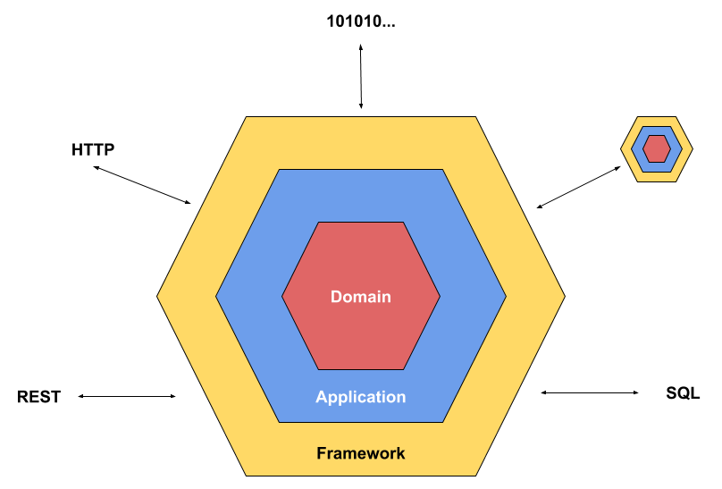
A CSPA Adaptor will then be the technical “glue” for binding the CSPA Service to a local statistical organisation’s environment while still retaining the core business logic of the Service.
It is important to notice that a CSPA service itself can also be used by other CSPA services in the role of an adapter for a certain task, if needed

As the driving philosophy of the CSPA services is that they are to be designed to be reused the adaptors are a key part of this approach as they allow the original development team to clearly identify what the supporting processes for the core logic are and how they are currently implemented.

As most actual implementations will be based upon common software engineering principles including DRY (Don’t Repeat Yourself) and Single responsibility, the logical identification and documentation of this adaptor functionality should be very easy to achieve for each of the services, modules or libraries involved. Where the principle CSPA service is constructed of a large number of microservices it is anticipated that each are likely to reuse common base capabilities which can be treated in the same way rather than needing to be repeating the same documentation for every instance of the service.

In being clearly itemised as part of the CSPA services the adaptor documentation then immediately supports any other teams considering reusing a CSPA service in being able to review and accurately evaluate the work required for them to modify these services adaptors in order to allow the valuable core logic to run in their own environment.

This is a key capability of the standard as the international statistical community is comprised of many specialists using a very wide range of different computing platforms so it is vital that the validated core functions can be moved as independently as possible.

Adaptors facilitate this by abstracting out and listing all of the non-core functionality that touches the supporting infrastructure, or other adaptors, each of which can then be reviewed and migrated individually until they all compatible and thus the principle service itself can now run on the new target with the required authentication, queuing, database etc.

The physical implementation of the adaptors within the codebase is not as important as the logical identification as different platforms, languages, standards and toolsets will all have a bearing on what best practice looks like for a specific development team.

For each statistical organisation team considering porting a specific CSPA service, being able to easily identify what each adaptor is, what it is intended to do and what it in turn requires to operate so the scope of change can be determined.

A formal set of adaptor documentation templates to hold this information as an extension to the existing CSPA documentation templates is required as well as a possible independent searchable repository so that teams could share adaptor code to again reduce the time taken to adopt a CSPA service by modifying other teams proven code examples.

Integration Patterns
CSPA services should be able to work within different integration patterns. The following patterns are identified as commonly used:

- Point-to-point
- Orchestration
- Event-driven, Publish/Subscribe

All integration patterns require either synchronous or asynchronous interaction between the services, message brokers, orchestration engines, etc. By implementing relevant adapters that supports these interactions, a CSPA service will fit into any chosen pattern, or mix of patterns. A service core may by design be built to generate events from state changes.

Within statistical production, multiple patterns will be used to solve different problems, for example, an event-driven approach may be suitable for metadata service integrations while point-to-point may be suitable for integrations where large datasets are exchanged.

Asynchronous

Orchestration
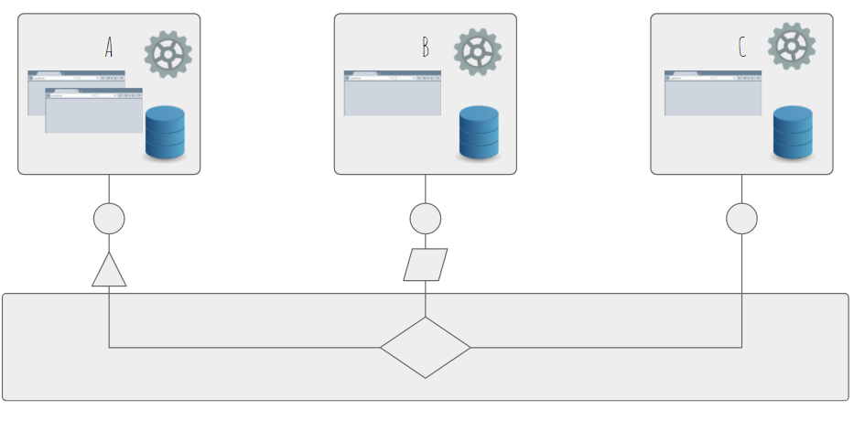
A central orchestration engine manages interaction between services and decouples the services from each other.

Point-To-Point
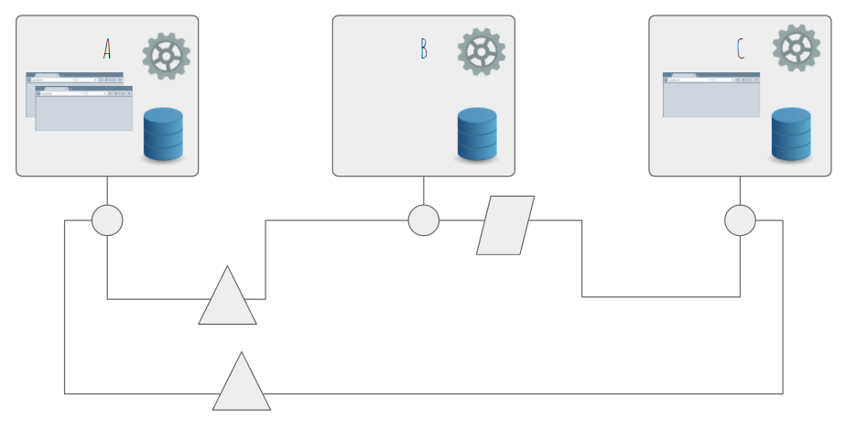
Data flows directly between two services. The calling service has knowledge about the other service.

Pub/Sub
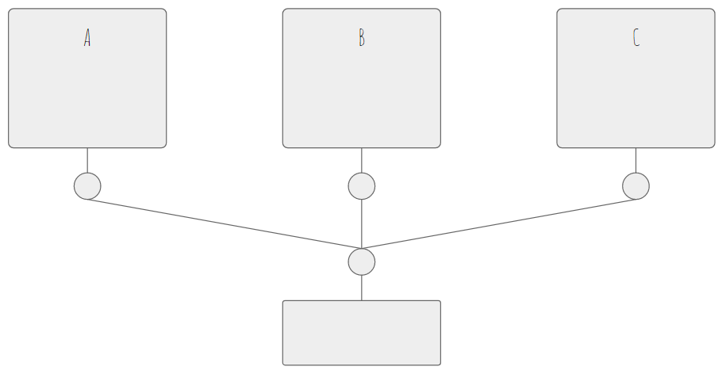
Services(publishers) sends messages(events) to some central hub that distributes the messages to subscribing services(subscribers). An event is generated when something has happened within the publisher.

Synchronous

Request/Response

Security
TODO: Must be configurable

Authentication
TODO: Should be able to write your own

Authorisation

Auditing

Manageability
TODO: Should be in the core.

Logging
TODO: Ex Logging i 3 levels

Monitoring

Portability

Containers

Moving from legacy architecture to service oriented architecture
TODO:

https://en.wikipedia.org/wiki/Single_responsibility_principle
https://marcus-biel.com/hexagonal-architecture/
https://en.wikipedia.org/wiki/Single_responsibility_principle

